

SHREWSBURY TOWN COUNCIL
APPROACH TO THE
ADOPTION & MANAGEMENT
OF OPEN SPACE ON
NEW DEVELOPMENTS

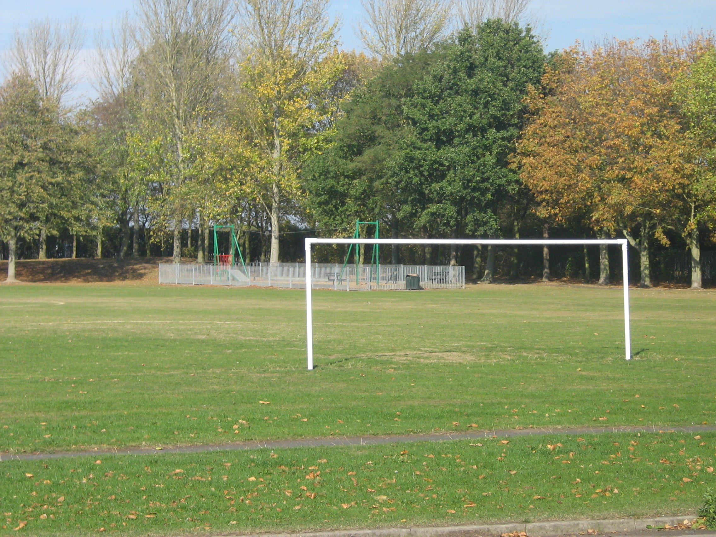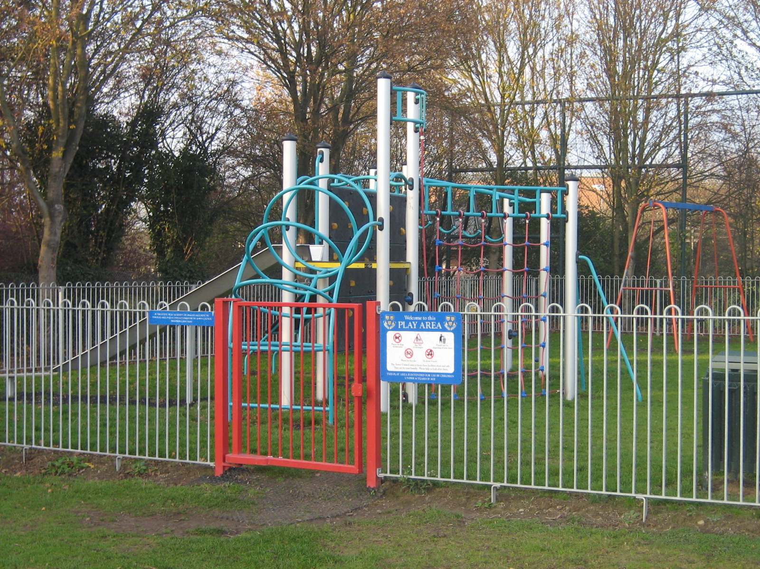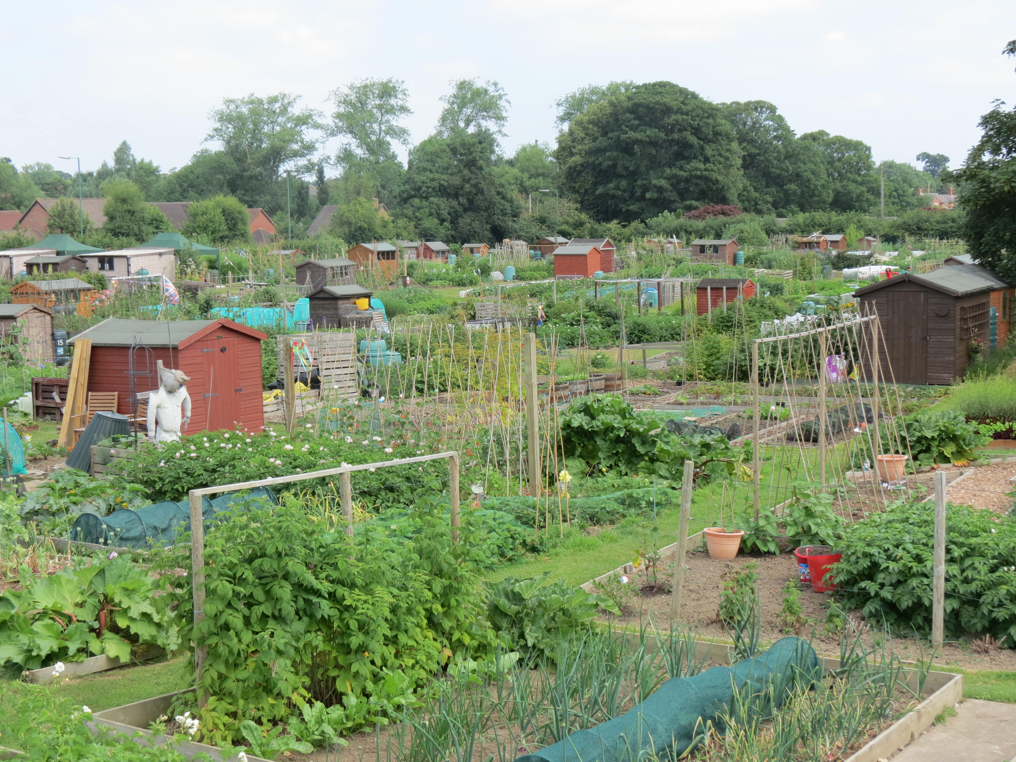

December 2017
1 Introduction

This guidance aims to encourage and inspire those involved in developing open space to create useful, sustainable and well-used places, which will benefit the wider community, the environment and support a healthy economy.
Shrewsbury Town Council is amenable to adopt open space as long as:

- The provision meets the appropriate quality standards at the time of adoption;

- The developer provides a commuted sum to the Town Council on or before the date of adoption sufficient to fund the management and maintenance for a period of 15 years (which is deemed not unreasonable bearing in mind that the Town Council will be responsible for maintaining the open space in perpetuity);

- The developer pays all legal costs relating to the transfer of the land or facilities to the Town Council

2 Why Open Space is Important

Open space has environmental, social and economic benefits and is therefore an essential component of sustainable development. Access to good quality open space is important in contributing to a greener, healthier, smarter, stronger, wealthier and fairer town.

Open spaces are people’s places. They act as green lungs for the town and make neighbourhoods attractive places where people want to live and work. They also act as wildlife corridors.

Open spaces are vital for encouraging biodiversity and provide ecological systems that absorb pollutants and rainwater, mitigate flooding and provide shade and cooling.

Open spaces are places for informal recreation, important for our physical and mental well-being. They can play a big part in building community cohesion, can stimulate the economy and attract enterprise.

3 What Shrewsbury Town Council looks after?

Shrewsbury Town Council has a broad range of open space that it is responsible for managing including:

- Formal Parks
- Informal Pocket Parks
- Play Areas for all ages
- Multi-Use Games Areas
- Multi-sport Recreational Grounds
- Football Pitches
- Cricket Wickets
- Bowling Greens & Croquet Lawns
- Tennis Courts (both grass and hardstanding)
- Artificial Football Pitches
- Golf course
- Skateparks & BMX Tracks
- Allotments
- Natural Greenspace including Woodlands, Countryside land and Sites of Special Scientific Interest
- Lakes, streams

Open spaces have a number of necessary infrastructure to maintain maximum use; these include:

- Pavilions
- Changing Facilities
- Lighting
- CCTV
- Carparking
- Seating
- Waste receptacles
- Fencing and Gating
- Signage

Our residents, visitors and workers to the town have different needs for open space and our open space estate is managed to meet as wide a need as possible.

These various open spaces require various management and maintenance regimes. The management of turf is a complex one with differing turf mixes requiring differing cutting regimes, with differing equipment.

4 Open Space in New Developments

This section is designed to set the standards by which we would expect open space to be developed on new developments so that:

- It provides the community benefit required;
- It integrates well with existing open space; and
- It is planned with long-term sustainability in mind.

Various open space audits of the town have outlined abundance in open space therefore current needs are focused on higher quality and more accessibility to open space rather than simple quantitative provision. For this reason quality and accessibility as well as quantity are the defining standards for open space development in Shrewsbury.

5 General Requirements in designing Open Space

It is expected that Open Space shall be laid out as part of on-site design. Future maintenance should be funded via a separate agreement with the Town Council.

Detailed below are the requirements the Town Council would wish to see addressed before any formal adoption of land to take place:

Land Ownership/Responsibility

- Developers must confirm exact boundaries and any boundary responsibilities, including ownership of any hedgerows and watercourses;

- The Town Council requires confirmation that there are no past mine/landfill and/or contamination issues, way leaves for sewers/cables that would compromise the ability of the Town Council to maintain the site as a recreational open space;

- The Town Council requires confirmation as to the extent of any potential flooding and whether there have been any Flood Management Plans developed;

- It is expected that any hedgerow adjoining development boundaries shall be conveyed to the property and not form part of any land adoption proposal;

- There may be an occasions where development boundaries cross over parish boundaries. Whilst the Town Council is happy to undertake grounds maintenance, there may need to be discussions with neighbouring Parish Councils.

Design

- Open space should be seen as an important community facility and an asset to developments rather than a parcel of land which has no development opportunity; therefore we would expect that our input into development is a forethought rather than an afterthought;

- Long-term management and maintenance should be considered at the outset to ensure the most appropriate materials, design and specification;

- Developments should look to be connecting with existing open space to create green space corridors and suitable walking and cycling routes to ensure maximum connectivity;

- Local circumstances should be considered in how open space is developed. Much of the town’s wish list regarding open space is featured in the Shrewsbury Placeplan;

- Quality and function are as important as quantity; this avoids any duplication and unnecessary maintenance burden;

- In designing open space there should be sufficient space to allow for informal recreational space/kick about space.

Land Use

- Open spaces must have a clear defined purpose;

- Open space should be multi-functional offering broad opportunities for outdoor recreation;

- Open spaces should be flexible so that they can be adapted to meet changing demands and circumstances;

Landscaping

- Open space should incorporate as many existing features as possible including watercourses, trees & woodland, wetland, heritage features, paths & desire lines. This may include Sustainable Urban Drainage Schemes, the maintenance of which sits more with grounds maintenance than equipment engineering;

- Site should be checked for persistent notifiable weed problems including Japanese Knotweed and Himalayan Balsam and an appropriate plan for control in place;

- All trees to be retained on site should be inspected and all remedial work as identified in an action plan addressed;

Security

- Open spaces should take into account security issues;

- All open space should be secured and fenced to prevent any unauthorised use. Any gates should be lockable and where appropriate lockable bollards should be used;

Infrastructure

- Public art should be provided where appropriate to reflect the local heritage, promote distinctiveness and add additional interest;

- In locating receptacles to collect litter and dog fouling consideration needs to be given to the ability to access areas for collection and the type of receptacle to ease collection;

Connectivity

- Paths should be connected, comfortable, convenient, convivial and conspicuous, where suitable tarmacadam surfacing should be used to avoid future maintenance. Lighting should also be considered so as to avoid areas of darkness and seclusion and ultimately anti-social behaviour;

- Accessibility to the open space from the adopted highway needs to be provided, with appropriate gating and removable bollards which would allow vehicles 2 metres wide to access

6 Play Space Design Guidance

It is expected that an agreed space shall be designated and the site prepared (including fencing) for the installation of play equipment as part of on-site design. Play equipment and its future maintenance shall be funded through the Community Element of the Community Infrastructure Levy retained by the Planning Authority. The Town Council is happy to consider design and build.

Detailed below are the requirements the Town Council would wish to see addressed before any formal adoption of a play area to take place:

- Play should meet the following requirements:

Number of properties | Play Area Type | Size | Age Range
100 properties | Local Area of Play (LAP) | 250m² | Under 6
150 properties | Local Equipped Area of Play (LEAP) | 375m² | 4-12
250 properties | LAP & LEAP | 625m² | 0-12
350 properties | Neighbourhood Equipped Area of Play (NEAP) | 875m² | 0-14

- Play provision needs to be appropriate to the needs of the community and should be accessible for every child within appropriate walking distance without having to cross main roads, railways or watercourses;

- The location of play should be influenced by the site, shape and contours of the development site and its relationship to surrounding developments and communities;

- Play areas should be accessible enough that parents should feel confident about where their children are playing; within visibility of neighbouring properties and along well used pedestrian routes. They should be sited close enough to housing that encourages informal parental supervision, but is not disruptive to residents enjoyment of their properties. Any new proposed LEAPs should be 25 metres away from the nearest residential building wall, whilst NEAPs should be 50 metres away;

- Play areas should be accessible from paths to enable enjoyable during inclement weather. Surfaces within the play area and the access to them from nearby paths must be free draining so they do not become water-logged or boggy after heavy rain and/or flooding. Where appropriate tarmacadam paths should be used to avoid future maintenance;

- Any gradients should be compliant with the Equality Act and should not cause an unnecessary maintenance burden;

- Consideration should be given to the use of materials that would provide a long-term, robust (steel construction) solution to play. Materials should stimulate the senses in terms of colour, sound and touch. Any construction should allow for spare parts to be easily accessible;

- Play equipment should be inclusive and accessible to all;

- Surfacing would be limited to either wet pour or specialist safety matting to ensure children’s safety, resistant to vandalism and an unnecessary maintenance burden;

- All play areas should be fenced off with dog-proof 1.2metre bow top fencing with two self-closing, self-clamping/anti-slam gates, one of which should be 2 metres wide to facilitate maintenance. Gates should be of a different colour to fencing;

- Seating and litter bins should be provided within the play area. Bins should be enclosed, lockable and of steel construction and approved by the Town Council for maintenance and emptying purposes. Seating should also be of metal construction to reduce future maintenance;

- It is envisaged that all Play Areas shall be sited close enough to lit paths so that additional lighting would not be required;

- Where on-site provision is not feasible, Shrewsbury Town Council will use the commuted sum to upgrade existing play facilities in the area.

- No planting should be provided within the fenced play area. Appropriate screening in acceptable to reduce noise pollution, but this should not cause the play facility to become isolated and out of view;

- The Town Council has a defined format for signage to all of its play areas, which details contact information and any rules for the facility;

- The number and type of equipment shall be in accordance with the NPFA’s 6-acre standard providing robust equipment that ensures no unnecessary maintenance burden;

- A post-construction inspection by ROSPA must be undertaken prior to adoption.

- Should there be a delay between the construction of the play area/ROSPA Inspection and the land adoption, the Developer shall carry out weekly inspection in the same way the Town Council would carry out weekly inspections.
7 Natural Greenspace/Countryside Design Guidance

It is expected that Open Space shall be laid out as part of on-site design to an agreed Management Plan

Detailed below are the requirements the Town Council would wish to see addressed before any formal adoption of land to take place:

- Should have a natural appearance and include minimal man-made artificial features promoting a sense of nature and tranquillity;

- Should promote contact with nature;

- Should include recognisable and where possible local, native species and habitats such as wildflower meadows, grassland, woodland, scrubland and open water;

- Should allow people to easily identify with and get a sense of which season it is;

- Should provide opportunities for exploration and/or natural play through the existence of varied habitat;

- Accessibility to the open space from the adopted highway needs to be provided, with appropriate gating and removable bollards which would allow vehicles 2 metres wide to access;

- Greenspace should be laid out in such a manner that would facilitate the use of mechanical maintenance equipment (grass cutters, tractors, flails, bailers etc.) rather than pedestrian equipment;

- It is expected that pedestrian desire lines have been considered so that those natural pathways can be mowed out easily;

- Any natural space may incorporate a Sustainable Urban Drainage Scheme. These areas need to be easily accessible for maintenance machinery (see separate section on SUDs).

8 Allotment Design Guidance

It is expected that Open Space shall be laid out as part of on-site design

Detailed below are the requirements the Town Council would wish to see addressed before any formal adoption of land to take place:

- The Town Council requires confirmation that there are no past mine/landfill, flooding and/or contamination issues, cables/pipes, etc that would compromise the ability of the Town Council to maintain the site as an open space;

- The site should be safe and secure with appropriate security fencing and gates allowing maintenance vehicles to the width of 2 metres access;

- Car access to the gate off the highway shall be constructed with appropriate on-site parking (1 parking space per 10 plot);

- There shall be a lockable communal storage, meeting space, compostable toilets, noticeboards and hardstanding to store manure/woodchip etc on site. Also each plot will be provided with a 6x4 shed and a small greenhouse plot as specified;

- Plots shall be laid out with appropriate paths; there shall be a mix of plot sizes to meet the differing needs of allotment holders;
- The site shall support bio-diversity through communal planting, hedging and wildlife schemes;

- Provision shall be made for appropriate drainage;

- Metered water supply shall be installed with 1 standpipe per 10-15 plots;

- Water capture facilities should be available on each plot;

- Compost Bins shall be available on each plot;

- Sheds shall be installed on site, constructed of wood and no greater than 8’ x 6’;

- Equality Act compliant compostable toilet provision should be considered;

- Communal store and meeting space should be incorporated on-site;

- Appropriate Signage showing plat layout, location of communal facilities and contact details.

9 Sustainable Urban Drainage Schemes (SUDS)

The Town Council will not adopt any SUDS scheme where it is considered that this will expose the Town Council to onerous risks or ongoing liability as the occupier of the land;

As such the Town Council will only adopt SUDS ponds and wetland areas that are within an area which is or shall become a public open space and consequentially shall be maintained in the same way as that open space;

Any flood mitigation ponds which are unlikely to hold permanent water must be constructed to have banks of no greater than 14° to allow for routine grass cutters to maintain the area when dry;

If any flood mitigation ponds are to be constructed that are likely to hold permanent water, these areas must be fenced off and appropriate life-saving equipment installed;

Any underground water tanks which are to be sited under public open space which is to be adopted by the Town Council must be able to withstand the weight of a 2 tonne grass cutter passing over it.

The Council will not adopt any communicating/connecting pipework from any retaining pond to any underground tanks or outflow to the sewage undertakers demarcation chambers.

10 Town Council’s Involvement in the management of Highway Verges

The Town Council is contracted to maintain Highway Verges, Hedgerow and Trees across the whole of the town. Where any development site involves the construction of these areas, future maintenance of such must be negotiated with the Highways Development Control Team at Shropshire Council as part of any s138 Highway Adoption Process and Shropshire Council will in turn discuss changes to our Service Level Agreement.

From a Highway verge maintenance point of view, the following areas should be considered:

- Any obstacles within the verge (trees, street lights, bollards etc.) will incur extra grounds maintenance charges (possible use of smaller, more timely equipment; weed killing etc) so should be kept to a minimum;

- Obstacles should be installed at the back of verges;

- Any bulb planting should be done at the back of the verge given the need to leave the site unmown for 6 weeks after the bulb finishes to flower

- The planting of grass in very small areas adjacent to the highway (e.g. Splitter Islands) should be avoided as future maintenance could place the grounds maintenance operative at risk. Alternative hard landscaping should be considered.

11 Maintenance & Management of Open Space
Shrewsbury Town Council is amenable to adopt open space as long as:

- The provision meets the appropriate quality standards at the time of adoption;

- The developer provides a commuted sum to the Town Council on or before the date of adoption sufficient to fund the management and maintenance for a period of 15 years (which is deemed not unreasonable bearing in mind theta the Town Council will be responsible for maintaining the open space in perpetuity);

- The developer pays all legal costs relating to the transfer of the land or facilities to the Town Council

Planning policy emphasises that appropriate maintenance and management arrangements are essential to the quality of the open space environment. Whilst the planning system has limited control over open space maintenance, it can make provisions through planning conditions and s106 agreements.

Here in Shrewsbury there is a huge expectation regarding the quality of open space and the Town Council prides itself in managing good quality facilities. It is expected therefore that any new open space should meet the same standards at the time of adoption to ensure parity across the town.

Management of open spaces requires a long-term perspective, with flexibility to respond and adapt to issues or changes such as community needs and priorities, biodiversity, climate change, improvements to access, quality, safety and competing uses. A maintenance plan should involve the following:

- Grass cutting
- Shrub maintenance
- Tree work
- Maintenance of furniture (benches, bins, lamps, bollards, signs etc)
- Bin emptying
- Hedge cutting
- Replacement of vandalised equipment
- Annual ROSPA Inspection
- Annual Risk Assessment
- Overlay footpaths
- Replacement of safety surfacing

It is therefore vital that maintenance and management implications are given full consideration alongside the planning and design of open spaces.

The Town Council shall look to ensuring that provision is made for:

- Well-designed informal open space for quiet relaxation on site;
- Appropriate children’s play facilities which are visible from nearby houses but not so close they would cause disturbance;
- Outdoor sport is accessible by walking, cycling and public transport.

New developments can have a significant impact upon existing recreation and leisure provision, putting pressure on existing resources and creating new demands for facilities from all sections of the community. The Town Council will need to be assured that the new development provides enough facilities to meet the needs generated by that development.

12 Town Council Advice to Developers

Pre-application Discussions
Discussions regarding open space requirements should take place at an early stage in the formulation of any development proposals; this is critical in determining the ultimate form and acceptability of a particular project. Officers would be keen to understand how a development will (i) incorporate the maximum amount of greenspace, (ii) how it would either link to or enhance existing provision and (iii) ultimately what are the management and maintenance desires of the developer. It is envisaged at this stage the Town Council should be in a position to provide am in-principle agreement on the adoption of open space.

Planning Application Submission
Historically many planning applications have been approved subject to conditions requiring the finalisation of the precise details of open space, location of play areas and appropriate maintenance plans. The Town Council will not provide extensive officer expertise and support until it is content that there is a genuine willingness of the part of the developer for the open space to be adopted by the Town Council. Officers have in the past provided technical support on management and maintenance to find that this has been used to prepare the necessary specification for maintenance by a third party. The Town Council will work with colleagues from the Planning Authority to ensure a more comprehensive approach to any agreements.

Post-Planning Approval
The Town Council shall work with the Planning Authority and the Developer to enter into a s106 agreement, to agree the adoption and level of developer contribution towards on-going maintenance. The town Council shall provide an indication of the sum of money to be paid to the Town Council (this however would be subject to certain timescales on completion).

Costs shall be developed by senior officers of the Town Council in conjunction with the local wad member. A total maintenance price for a year would be calculated and multiplied by 15 years to give a final maintenance figure. The Developer contribution once paid over to the Town Council would be invested and released annually into the Town Council’s annual revenue budget

Checklist to enable Adoption

Landscape & Setting
Has the Developer confirmed that there are no past mine/landfill, flooding and/or contamination issues attached to the site?
Has there been opportunities for Town Council Staff to walk around the site either independently of or with the developer?
Has a Management/Maintenance Plan been drafted/agreed with the Planning Authority and its relevant Stakeholders?
Has the developer supplied maps to Town Council Staff outlining:
- Boundaries and maintenance responsibilities
- Types of Open Space including size
- Context of development site to existing communities/recreational facilities
Has the Highways & Public Rights of Way Teams at Shropshire Council been consulted over any footpath/roadways particularly where they may be a requirement for the Town Council to maintain hedgerows, highway trees and grass verges on behalf of Shropshire Council.
Has the matter of SUDs been discussed with Shropshire Council as the responsibility for such would rest with a separate provider and not the Town Council?
Has the land for adoption been regularly inspected and maintained by the developer prior to handover?
Greenspace
What is being retained in terms of hedges, trees and water courses?
Have all retained trees been inspected and appropriate actions carried out ahead of adoption?
Has the site been inspected for persistent notifiable weed problems including Japanese Knotweed and Himalayan Balsam and the appropriate actions carried out ahead of adoption?
Have any pathways been laid out to specification?
Play Area
Type of Play Area – LAP, LEAP, NEAP
Proximity to Housing
Fencing – 1.2m bow-top with 2 self-closing gates, and one gate to be 2m wider to facilitate maintenance
Predominantly steel equipment from a reputable supplier with ability to deliver spare parts
Bins – steel, lockable
Benches – steel
Safety Surfacing meets acceptable standard
STC approved signage

