THE SHROPSHIRE COUNCIL
(BOROUGH OF SHREWSBURY & ATCHAM) (NO. 1)
(SPEED LIMITS) ORDER 2006 (AMENDMENT NO. 2) ORDER 2016

Shropshire Council (hereinafter referred to as “the Council”), in exercise of their powers under Sections 84(1) and (2), and 82(2) of, and Part IV of Schedule 9 to, the Road Traffic Regulation Act 1984 (“the Act”), and of all other enabling powers and after consultation with the Chief Officer of Police in accordance with Part III of Schedule 9 of the Act, hereby make the following Order:

1. Schedule 7 (De-Restricted Roads) and Schedule 8 (20mph Speed Limit Zone) of The County Council of Shropshire (Borough of Shrewsbury & Atcham) (No. 1) (Speed Limits) Order 2006 are hereby amended by the addition of the lengths of roads specified in the Schedule to this order.

2. This Order shall come into operation on 11 November 2016 and may be cited as The Shropshire Council (Borough of Shrewsbury & Atcham) (No. 1) (Speed Limits) Order 2006 (Amendment No. 2) Order 2016.

3. The prohibitions and restrictions imposed by this Order shall be in addition to and not in derogation from any restriction or requirement imposed by any regulation made or having effect as if made under the Act or by or under any other enactment.

THE COMMON SEAL of THE )
SHROPSHIRE COUNCIL was ) LS
affixed hereto the 9th day of )
November 2016 in the presence of: )

T W Collard
Legal Services Manager

SCHEDULE

De-Restricted Roads

20mph Speed Limit Zone

Lengths of roads in Shrewsbury in the County of Shropshire

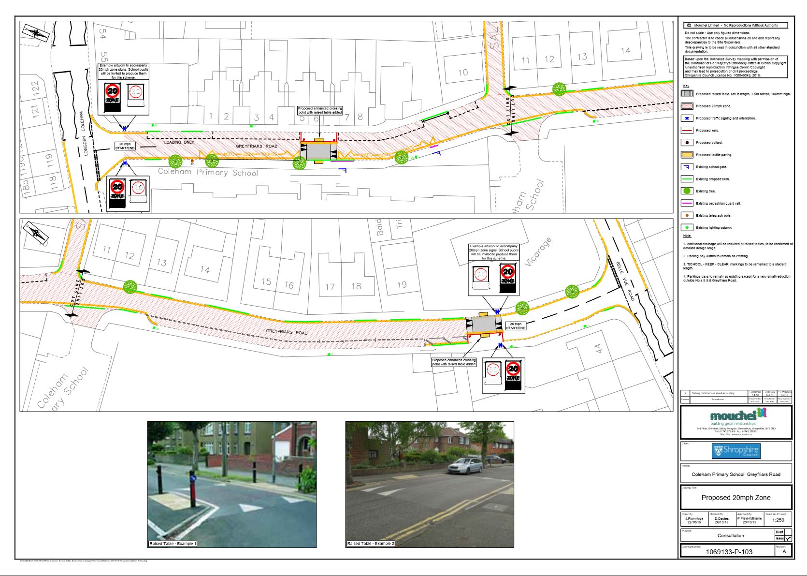
Greyfriars Road from its junction with Longden Coleham in southerly direction to a point 30m north of its junction with Belle Vue Road. Salters Lane for its full length.
Agenda No
5.1

