 |  | Shrewsbury Town Council :Full Council meeting  25TH June 2018 |  | Item  Public
Agenda No

13

sHREWSBURY hIGHWAY mATtERS.

Responsible Officer |  | Steven Brown
Email: | steven.brown@shropshire.gov.uk |  | Tel: | 07990 085581 | Fax:

Summary

An invite was received from the Town Clerk to attend Shrewsbury Town Council, Full Council meeting. The issues invited to be to be discussed by officers attending are:-

- The development of the Shrewsbury Integrated Transport Plan and the need to understand the bigger picture rather than comment on piecemeal projects.

- The likelihood for funding for the North West Relief Road.

- The likelihood and potential impact of closing the Harlescott Railway Crossing.

- The recent decision of Shropshire Council not to support a county-wide “Twenty Is Plenty” campaign.

- The effectiveness of the Sites of Road Safety Concern Programme and this particularly more so in light of a lot of projects in Shrewsbury raised through that Programme have now been removed from the Capital Programme following £5m cuts in Highways funding.

- The bedding in of the Kier Contract

REPORT

Shrewsbury Integrated Transport Plan.

The Marches Local Enterprise Partnership (LEP) has identified Shrewsbury as an ‘urban powerhouse’ and ‘growth point’, and therefore key to the economic wellbeing of Shropshire. It also acknowledges the SITP as a priority project for Shropshire because of the important role transport plays in a successful economy.

Consultation

The SITP consists of a number of schemes including improvements to key junctions, the enhancement of the pedestrian/cycle networks, way-finding strategy implementation, and town centre public realm improvements. Shropshire Council, in

collaboration with designers at WSP, completed initial designs for each of these schemes, which were put out to public consultation to ensure that any affected or interested parties could comment on the full SITP package prior to commencing detailed designs.

To ensure that as many affected or interested parties as possible could be informed about the SITP and how to get involved, various forms of consultation were undertaken between 9th February and 29th March 2016. The consultation period lasted for a period of six weeks.

Many forms of consultation were undertaken, including public exhibition events, radio interviews, and online material, press releases and briefings, and stakeholder workshop meetings;

19/01/16 - Shrewsbury River Loop Meeting
27/02/16 –BID Board
08/02/16 - Shrewsbury Town Residents
08/02/16 - Cllrs Fraser and Bannerman
08/02/16 – Friends of the Earth
11/02/16 – BBC Radio Shropshire and Free Radio Interviews
11/02/16 - BID Exhibition Preview
12/02/16 & 13/02/16 - Public Exhibition
18/02/16 - Meole Residents Meeting
23/02/16 - Shrewsbury Town Council
25/02/16 - Market Hall Management
01/03/16 – Shopmobility
03/03/16 - Shropshire Wheelchair Group
11/03/16 - Access Group
15/03/16 - Shrewsbury Business Chamber
15/03/16 - Shrewsbury Cycle Group
17/03/16 - Town Centre Residents
18/03/16 - Guide Dogs

The results from this consultation process were analysed and consolidated into a consultation report considered and approved by Cabinet in June 2016. The local MP was briefed 22nd July 2016.
This report has been in the public domain since its approval by Cabinet, along with the SITP Programmes wider commitments since late 2015.

The full consultation report can be viewed at;

https://www.shropshire.gov.uk/media/4257/sitp-consultation-report.pdf

SITP Funding

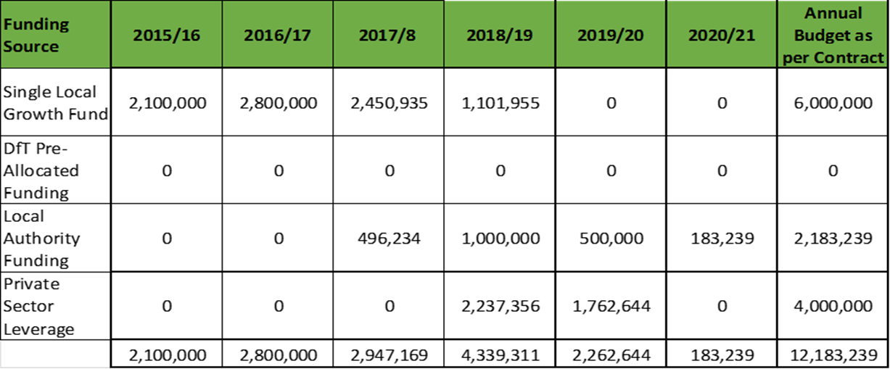

Table 1. SITP external grant funding and match funding profile.

The above funding profile, and the associated risk of overspend at the Councils expense, was agreed by Council Members as part of the Cabinet 17th Feb 2016 Financial Strategy Report.

Funding for the proposed SITP has been secured and will comprise a total of £12.18m of investment in the town. This has been secured through the following sources:
- c.50% funded through The Marches LEP Regional Growth Fund

- c.50% funded through Shropshire Council’s developer contributions (split in table 2 as “Local Authority Funding” and Private Sector Leverage” which combines CiL contributions and s.106 monies)

The Growth Deal funding, submitted Outline Business case (OBC), and also the fixed funding allocations in year and in total, are also subject to a signed grant funding agreement following this Cabinet report, between Shropshire Councils s.151 Officer and the Marches LEP.

SITP Background

To secure funding for the SITP, Shropshire Council submitted an OBC to The Marches LEP which demonstrates how the SITP will support the delivery of long-term economic benefits and sustainable growth for Shrewsbury and the surrounding area.

The SITP aligns closely with a number of national, regional and local policy documents. These include The Marches Strategic Economic Plan, Local Transport Plan, Local Development Framework, Place Plan, and regeneration plans. These strategies make it clear that transport investment should benefit all modes of transport and respect and enhance the environment.

The core objectives of the SITP are:

- To contribute to economic growth; new jobs and new homes

- To alleviate congestion on the inner relief road; improving key junctions, and altering junction priorities

- To reduce the volume of traffic flows through the historic and commercial town centre

- To improve the reliability of journey times; for commuters and visitors travelling in and out of Shrewsbury

- To improve air quality in the town centre

- To encourage sustainable modes of transport by adding missing links to current pedestrian and cycle routes

- To enhance the built environment; which will promote a more positive experience and the visitor economy

- To improve safety for all road users, which will encourage the use of sustainable transport modes

The SITP is a package of transport measures designed to improve the transport system in Shrewsbury, and stimulate a new period of sustainable economic growth within the town and the surrounding area. The agreed package includes:

- Key junction improvements at Reabrook Roundabout, Meole Brace Roundabout, English Bridge Gyratory and Coleham Head. These would involve upgrading current highway infrastructure, including traffic signals to improve vehicle capacity and pedestrian and cycle facilities, with the aim of reducing congestion

- Implementing further phases of the SCOOT* network to improve traffic signal operation and manage traffic flows on main arterial routes. This would include new VMS (variable message signage), which would direct town centre through-traffic onto the inner relief road or, alternatively, towards car parks and park and ride facilities.

* SCOOT (split cycle offset optimisation technique) is a technology for managing and maximising the efficiency of traffic signal junctions in urban areas.

- Enhancements to pedestrian and cycle links to increase accessibility to the town centre for active and sustainable modes of transport, and improve awareness of these links in Shrewsbury

- Improved pedestrian wayfinding* within and around the ‘river loop’ to generate a highly accessible and connected town centre for pedestrians

*Wayfinding within SITP refers to information systems that guide people through and around the town, and enhance their understanding and experience of it.

- Enhancements to the public realm*, such as Pride Hill, Shrewsbury Square and Mardol to improve the public realm and highlight pedestrian facilities. This closely links to the traffic management measures

*The public realm refers to all the spaces between buildings that can be freely accessed, it encompasses all outdoor areas including roads, parks, squares, pedestrian routes and cycleways.

Agreed SITP delivery Programme

Location | Timescale
Key Junctions:  Meole Brace Roundabout  Reabrook Roundabout  Coleham Head  English Bridge Gyratory | 2016/2017  2017  2017/2018  2017/2018
SCOOT | 2016/2018
Pride Hill | 2018
Pedestrian Wayfinding | 2016-19
Town centre packages | 2018-19
Sustainable Corridors / Pedestrian and Cycle route Enhancement | 2019-20
Variable message signs | 2020

Progress to date against Delivery Programme

1 Meole Brace Roundabout – Complete (10 February to 30 May 2017)
Work to create a new link road and shared-use pathway through Meole Brace roundabout in Shrewsbury, and to upgrade the existing traffic signals at the island, began in October 2016.

This was the first construction work being carried out as part of the SITP aiming to discourage drivers from using the town centre as a through route, and to make better use of the town’s outer and inner ring roads instead.
The new road and pathway link at Meole Brace roundabout was created between Roman Road and the A5112 exit towards the A5.

Now completed, the roundabout has the extra capacity needed to accommodate future traffic levels and reduce congestion, and also has greatly improved pedestrian and cyclist facilities.

2 Sutton Park Roundabout – Complete (10 April to 7 May 2017)
Resurfacing works to accommodate highways planned maintenance programme within SITP

3 Reabrook Roundabout- Complete (8 May to 28 July 2017)
Work to improve and resurface the roundabout, including: carriageway widening to improve traffic flows; cycleway and footway crossing improvements; improved street lighting; drainage work, and resurfacing.

4 English Bridge Gyratory and Longden Coleham. – Complete (31 July to end October 2017). The upgrading of footway materials to improve the aesthetic appearance of the area; improvements to footway and cycle facilities along Abbey Foregate; and upgrading the traffic signals and pedestrian crossing facilities.

5 Foot of Wyle Cop- Complete (8 January to end March 2018)
Works included the upgrading of footway and kerbing materials with natural stone products, plus carriageway resurfacing. The completed scheme enhances and improves the area and completes and gives continuity to the new Abbey Foregate ‘gateway’ to the town centre.

6 Pride Hill – 30th April 2018 to November 2018

Comprehensive enhancement works include:
- Resurfacing the pedestrianised area with high-quality materials to reinforce the character of the street;
- Replacing existing street furniture to reflect the proposed high quality finish; (jointly managed through a joint project board with Shrewsbury Town Council and Shrewsbury BiD in terms of the design of furniture and planter units
- Delivering brand new Wayfinding infrastructure jointly with Shrewsbury Town Council and Shrewsbury BiD
- Reducing street clutter;
- Improving pedestrian connections at either end of the street;
- Emphasising key access points to the two shopping centres with the use of informal surface banding;
- Enhancing the setting of High Cross; and
- Retaining two of the three existing trees alongside increasing the number of planters.
Access to properties and businesses will be maintained at all times, with temporary pedestrian walkways being implemented where required. The contractor has pedestrian ambassadors and a public liaison officer on-site to assist with enquiries and access arrangements for deliveries during the construction works.

Future committed SITP phases will be delivered in line with the above programme.

SITP Project Management

Within the submitted OBC, the Councils approach to the design, management, procurement and delivery of the various elements of the SITP is detailed. In summary, these roles are broken down as;

  - Shropshire Council - Project Client - owns project risk and financial risk against Growth Deal spend profile, manages procurement of external contractors, accountable body for project outputs.
  - WSP – Project Manager (SC Term Consultants) – commissioned to design scheme elements and manage contractor activity through construction phases under the NEC contract principles.
  - External Contractors – (various) – Procured as required for each element of the SITP. The range of disciplines and specialisms required for each element, ranging from major civils works (Key Junctions Phase), to Public Realm enhancements (Town Centre Package) means that each element is procured separately as a stand-alone contract.

Procurement Approach and Constraints

Procurement Approach
Each SITP element is procured through Shropshire Councils standard procurement approach, and is overseen by the Councils Procurement Team. As with most construction contracts of this nature, the evaluation criteria are a mix of quality and price elements.

Quality elements include references and case studies of previous similar works undertaken and the option to interview and question a given contractors submission prior to award. Similar scrutiny is given to submitted costs before an award is made.

Procurement Constraints
- Cost – The SITP is being delivered against a fixed budget as prescribed by the Growth Deal funding agreement. Any costs over this set budget are the responsibility of Shropshire Council. Due to this, it is imperative that contract awards and costs are carefully managed in order to meet budget requirements. Given the sequential nature of the SITP works packages, over / underspend can be managed through adjustment of later SITP phases in terms of scope and engineering/design.

- Timescale – The SITP has a fixed 5 year delivery plan as agreed under the OBC. The Growth Deal funding is required to be spent in the allocated year/s, and no overrun of the SITP is permitted. Failure to meet agreed spend profiles could result in revisions to the external funding offer, or ultimately, clawback. The spend profile is required by the LEP to be managed and reported monthly throughout the 5 year delivery period.

- Quality – The SITP gives a rare opportunity for Shropshire Council to invest many millions of pounds of external funding in Shrewsbury. As such, the quality of design and completed works is critical to the overall success of the project. In pursuing this, the quality assessment of contractors and their previous track records of high quality delivery is a key factor in contract award. Further to the quality of the completed project, the impact on the town during the various construction phases is also fully acknowledged. The approach and track record of a contractor in managing disruption to a minimum, in working effectively with local highways network managers, and acknowledging the sensitivities around prolonged road closures is closely scrutinised as part of the tender evaluation process.

Summary

The SITP offers Shropshire Council an opportunity to greatly enhance the infrastructure of Shrewsbury, by drawing in external funding of c£12m in order to generate a number of key outputs;

  - Road, pedestrian and cycling infrastructure that is fit for purpose in meeting the planned growth in housing and employment within the town for the next 30 years.

  - A greatly enhanced town centre environment that supports the retention and growth of the shopping and tourism economy
  - Improvements that work in tandem with Shropshire Councils ownership, management and development of the two key shopping centres in the town.

  - A town centre that better meets the changing needs of the resident and the visitor in the town.

  - An opportunity to align the current improvements works with the developing ambitions of The Big Town Plan.

  - The chance to deliver on the joint ambitions for the town with partners and stakeholders including Shrewsbury Town Council and Shrewsbury BiD.

There are considerable challenges involved in this delivery, and the measures put in place to mitigate the impacts of the SITP programme. These challenges include;

  - Working on and around the highway for prolonged periods, over a 5 year period, whilst ensuring that traffic, business and pedestrian movements are impacted as little as possible. This is jointly managed with the Councils Street Works Team.

  - Ensuring that the positive messages around the improvements and investment continue to be understood by residents, businesses and visitors through proactive and effective communications.

  - Working to a set and prescribed programme of works, and a finite budget overall.

  - Acknowledging that within the 5 year programme, work post-dating its commencement around the Big Town Plan and other local initiatives require adaptation and further development of many of the key elements of the SITP to meet wider ambitions of the Council and stakeholders.

As the SITP has progressed to this point, it can be demonstrated that there has been constant refinement to the approaches taken in design, work programming, phasing, traffic management and communications. The SITP Project Management Team will continue to develop best practice in all of these areas, and will continue to consult with Key Stakeholders, including the town Council as future committed phases of the SITP move into delivery.

The likelihood for funding for the North West Relief Road

Shropshire Council was unfortunately not successful with its application for scheme funding under the recent round of the DfTs Large Local Majors programme. Following the December 2017 delivery to DfT of the comprehensive Outline Business Case (OBC) for the project, announcement of only three national scheme funding offers were made last month by DfT and the NWRR was not one of these.

The full OBC can be viewed at;

https://www.shropshire.gov.uk/roads-and-highways/roadworks-and-road-closures/large-scale-project-works/north-west-relief-road/

The day prior to the announcement Danial Kawczynski MP, and Cllr Steve Davenport (Portfolio Holder Highways and Transport) were in London lobbying Chris Grayling in support of the NWRR. Despite not being included in the recent funding announcement, there was an indication then that there may be subsequent announcements on other schemes later this year. This has not been ratified through DfT at the time of writing however, and further conversations continue at a political and officer level in order to clarify this.

The NWRR continues to be a priority scheme for Shropshire Council, and as such, further funding opportunities through Midlands Connect, and under DfTs proposed new “Major Road Network” are now also being explored.

The likelihood and potential impact of closing the Harlescott Railway Crossing

Network Rail has recently published its strategic five-year business plan (for the period 2019-24) and is now seeking the views of stakeholders. Including the Council, and others on a range of its proposals. One such proposal being made by Network Rail is to close Harlescott level crossing in Shrewsbury to traffic, and to instead install a bridge over for pedestrians/cyclists only. As the local Highways Authority, Shropshire Council manages the road network surrounding the Harlescott level crossing, and Network Rail manages the trackside element of the crossing.

More information about Network Rail’s business plan be found on their website at: https://www.networkrail.co.uk/feeds/network-rail-reveals-significant-investment-more-services-and-fewer-delays-in-its-five-year-plan/

Shropshire Council is now be taking a closer look at Network Rail’s proposals as part of this consultation, and giving further consideration to the potential impact of a

closure on traffic flows within the area and on the wider town highway network – as well as the likely impact if the crossing was to remain open in the light of increasing barrier down time due to increases in train movements and line speeds.

As part of the evaluation of these impacts, In late 2016 Network Rail commissioned Shropshire Council to undertake a traffic modelling exercise to look at the impact of a full closure of the Harlescott Crossing to vehicles, whilst retaining pedestrian and cycle access at the current crossing point. This information could be used to inform Network Rail’s proposal to close the crossing should this emerge as a priority for them after their current consultation.

At the time of writing the traffic modelling work is ongoing, based on the 2017 full town traffic model that was developed as part of the NWRR proposals. This is ensuring that all scenarios are based on the latest traffic flow information. Shropshire Council and Network Rail are currently managing the modelling and reporting project with regular meetings. These have oversight of the emerging changes to travel patterns based on the proposed closure, and as a second stage will then look at the requirements that there may be to update and invest in those junctions and road corridors that are impacted by changes in motorists travel habits around the local area, and more widely across the town.

Shropshire Council will continue to work closely with Network Rail as the study progresses, with the study expected to be complete in the late summer of 2018. Once complete, further informed discussions and consultation based on the study results will then be undertaken with key stakeholders by Network Rail and Shropshire Council. No decision on any future closure has yet been taken.

20’s Plenty.

The ‘20s plenty’ campaign looks to make 20mph the default speed limit on residential and urban streets, and as such adopts an area wide signed only approach. 20mph speed restrictions can demonstrate a positive relationship with public health, road accident severity, and quality of life and environmental benefits.
There is no specific programme for the implementation of 20mph schemes in Shropshire. Shropshire Council’s approach to introducing 20mph speed restrictions is embedded in its Road Safety Policy. The approach is based upon supporting the delivery of appropriate, proportionate, and achievable traffic management interventions in locations where the potential benefits are greatest and where specific road safety concerns have been identified, either through accident data analysis or through the community led road safety concern process. The choice of intervention may include a 20mph speed restriction.

Shropshire Council currently has an agreed approach for the implementation of 20mph speed restrictions on a site by site basis. In Shropshire, 20mph restrictions are currently only considered in the following locations:

- Outside schools or where there are high numbers of vulnerable road users;

- On urban residential streets in specific cases (where wide community support can be demonstrated, where there is evidence that streets are being used by

- people on foot and on bicycles and where the characteristics of the street are suitable) and,

- On town centre streets / pedestrian dominated areas.

At present and where appropriate, Shropshire Council already advocates design speeds of 20mph or below as part of any new residential developments. This is in accordance with current guidance contained in the Department for Transport’s Manual for Streets (2007 and 2010) which outlines the design principles for new and existing residential streets. This means that the physical design of the street layout is carried out in such a way to keep vehicle speeds low and means additional 20mph speed restrictions can be unnecessary and can introduce additional sign clutter.

Current guidance from the Department for Transport suggests that vehicle speeds must already be low before a signed only 20mph speed limit is introduced, so the extent to which a defined benefit can be achieved needs to be considered. There are further considerable financial and environmental implications for sites where traffic calming is deemed necessary to achieve low vehicle speeds, either as part of a scheme or post-implementation. It is important that the potential financial legacy of area-wide signed only 20mph speed restrictions is recognised.
Integrated Transport Budget.

In addition to identifying accident cluster sites on Shropshire’s highways, Shropshire Council’s Road Safety Policy also enables road safety concerns to be generated by the local community.

The policy enables town and parish councils to accept perceived local road safety concerns from the general public and then submit those that they support, and consider there to be a level of shared community concern, to Shropshire Council up to three times a year. Where supported by Shropshire Council’s traffic engineers, these submissions are prioritised using a robust approach and a programme of design and construction work is developed in line with available budget. The available budget must account for ongoing community led concern schemes that are already in the programme as well as new requests. Historically the demand for new schemes significantly exceeds the available budget.

Community led road safety schemes are funded from the Integrated Transport Block capital grant awarded by the Department for Transport. In the first instance, this grant is used to fund statutory functions in relation to introducing measures to reduce the risk of road traffic accidents at high priority sites. In addition, the grant also covers strategic transport initiatives, traffic signal enhancements, sustainable transport schemes and bus shelter grants.

Shropshire Council’s entire Highways and Transport capital budget has been reduced by £5m in the 2018/19 and 2019/20 financial years. As such, there has been a proportionate impact on the Integrated Transport work and consequently the community led concern element of Shropshire Council’s Road Safety Policy.

The reduction in budget means that after fulfilling Shropshire Council’s statutory duties in relation to accident data led schemes and post-scheme safety reviews, there are insufficient funds to progress many of the other elements of the Integrated Transport programme. Therefore, it has been necessary to put a number of Integrated Transport schemes generated from the community led concern process on hold until funding becomes available. We are currently envisaging that this will continue to be the case for the 2019/20 programme however this will be dependent on the number and nature of accident cluster sites identified.

The aim of the Highways and Transport service continues to be to provide safe and well-maintained roads across the county. Town and parish councils can continue to contact the local highways teams to discuss areas of concern and the extent to which urgent remedial action is required will be reviewed. However, the aforementioned budget restrictions mean that non-urgent requests are unlikely to be progressed.

Kier Contract.

Highways & Transport (H&T) is a service that delivers its responsibilities across seven days per week, 24 hours per day and 365 days per year. We receive on average 3,500 contacts per month.

The Kier contract began on April 1st 2018, and is a seven year contract with an approximate value of £21 million per year – (increase on core value dependent upon external funding awards / grants), with the ability to extend for a total of three additional years (1 year extensions x 3). The contract key areas are:-

- Highways Maintenance
- Highways Projects
- Capital works
- Bridges and Structures
- Vehicle Workshops
- Street Lighting
- Street Scene (street cleaning, grounds maintenance, fly tips, graffiti etc.)
- Signs and Lines
- Emergency and severe weather responses
- Drainage

The Kier contract is one of three core contracts that H&T operate

Kier £21.2 million per anum
WSP £2.5 million per anum
Dynniq £300,000 per anum

The H&T service is predominantly delivered via five operational depots:

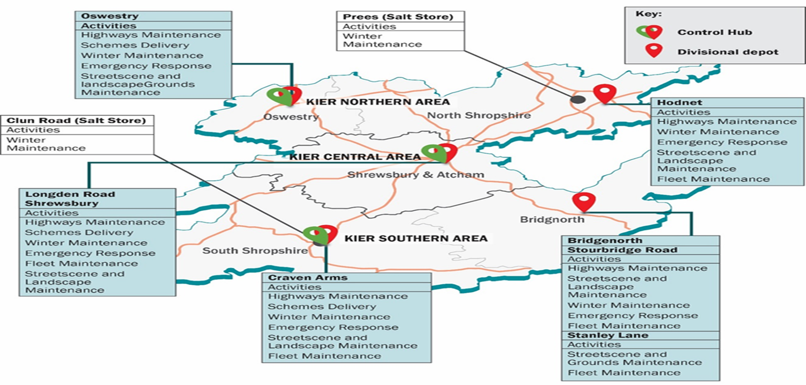

All depots provide ability, via Shropshire Highways (Shropshire Council, Kier and WSP) to provide responses and services within the resource allocations and responsibilities assigned.

Operational decisions are required in a dynamic service environment, and often these are ‘risk based’ decisions, as demand for services and responses always outweighs supply.

H&T is also governed and operates within the parameters of the following key documents. The National Code of Practice for Highways Authorities is designed to promote integrated asset management for highway infrastructure based on a risk-based approach to local service levels. The review of existing guidance has provided an opportunity not only to update advice to reflect the latest developments in the maintenance sector but also to bring a fundamental change in the way highway infrastructure is managed in the United Kingdom, through the adoption of a risk-based approach.
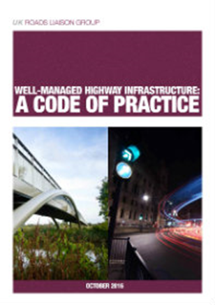

The document states that ‘a risk-based approach should be adopted for all aspects of highway infrastructure maintenance, including setting levels of service, inspections, responses, resilience, priorities and programmed.
Authorities are encouraged to develop appropriate records and make a detailed inventory of highways assets and keep the quality, currency, appropriateness and completeness of all data supporting asset management under regular review. A network hierarchy, or a series of related hierarchies, should be defined which include all elements of the highway network, including carriageways, footways, cycle routes, structures, lighting and rights of way. The hierarchy should take into account current and expected use, resilience, and local economic and social factors such as
Are managed via National agreed and established contract.


The mobilisation of the contract has completed and the contract is embedding, appointments to Kiers core staff are still being made, the recent appointment of a scoping manager, and the contract is being supported via other Kier staff. Any contract of this size needs to embed, so cultural changes, new systems and processes, IT, costs, rates, organisational culture.

At present the overview, is that the contract is performing well, relationships are positive, and practices such as co-location, NEC training, other accredited trading are supporting moving forward.

END.

