SHREWSBURY TOWN COUNCIL

RECREATION & LEISURE COMMITTEE

30 SEPTEMBER 2020

Responsible Officer: Gary Farmer – Head of Operations

TEAM SHREWSBURY UPDATE

Purpose of the Report

To receive an update on Team Shrewsbury

Meetings
Tactical meetings have resumed virtually on a monthly basis.

Weekly meetings are due to commence once IT issues have been resolved.

Purple Flag
Shrewsbury has retained its Purple Flag status for a thriving evening and night-time economy.

The Purple Flag campaign recognises excellence in town and city management, scoring against key criteria including wellbeing, broad appeal, the place as a destination and policy. The scheme operates in much the same way as Green Flag does for parks and Blue Flag for beaches.

Assessors found Shrewsbury to be a ‘very safe and secure town’ and commended Team Shrewsbury for its strong partnership approach to improving and responding to issues in the town.

WMP Town Office
Town Centre Police Station closing down by mid November. All Officers will be based from Monkmoor which reduces the response times for Town Centre issues i.e thefts, ASB, drug dealing etc.

World Homelessness Day
Events taking place w/c 5th October which incorporates World Mental Health Day on 8th October & World Homelessness Day on 10th October. Exhibitions will be arranged around the Town. Details will be posted on social media.

Exploitation & Vulnerability
West Mercia PCC are funding a 2 hour training session which is available for all Shrewsbury restaurants, café, shops etc - around recognising the signs of CSE/CE, County Lines etc.

WMP Volunteering Opportunities
WMP are working with University Centre Shrewsbury for student volunteers. An excellent opportunity for students to gain valuable experience by volunteering to work with SNT assisting the team with events, sharing messages re river safety, CSE, CE and modern slavery during the mobile police station surgeries etc.

Smartwater (We Don’t Buy Crime)
Bowbrook Estate is requesting that Council considers the Smartwater initiative due to an increase in burglaries. The PCC are currently offering a 25% contribution towards Smartwater and free of charge signage increasing the ‘We Don’t Buy Crime’ message. There is a minimum order of 80% of an area required to achieve the 25% discount. The costs per household is £6.80.

Incidents
The below shows a comparison of the main ASB incidents during the past 3 months compared to 2019.

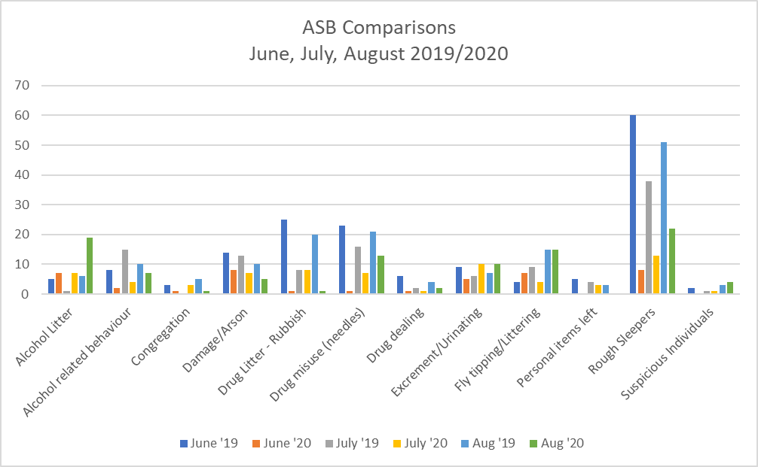

RECOMMENDED:

- That the Council considers funding the Smartwater initiative on Estates where they are experiencing high crime rates

- That the Council That the Report be noted

