SHREWSBURY TOWN COUNCIL
RECREATION & LEISURE COMMITTEE

10 OCTOBER 2018

Responsible Officer: Helen Ball - Town Clerk

Bus Shelters

Purpose of Report

To update members on the number, type, condition and location of bus shelters
To determine a programme for upgrade
To determine a policy for the consideration of installation of new bus shelters

Background

The Town Council inherited 109 Bus Shelters from SABC in 2009 (list appended to this report. They fall into two distinct types:

Version 1

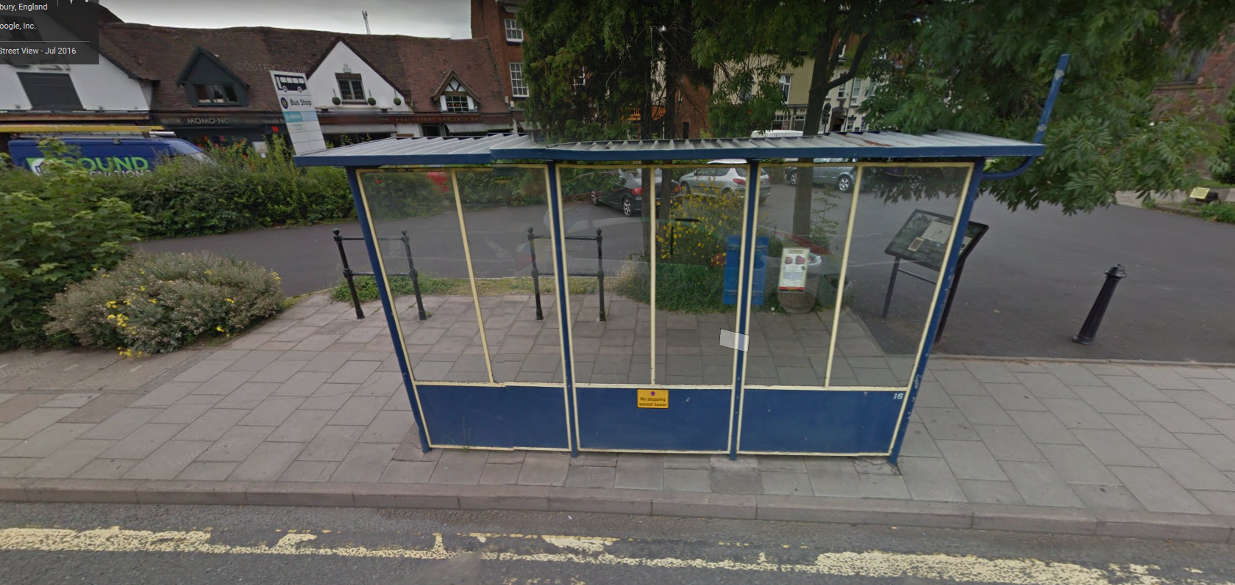

Version 2

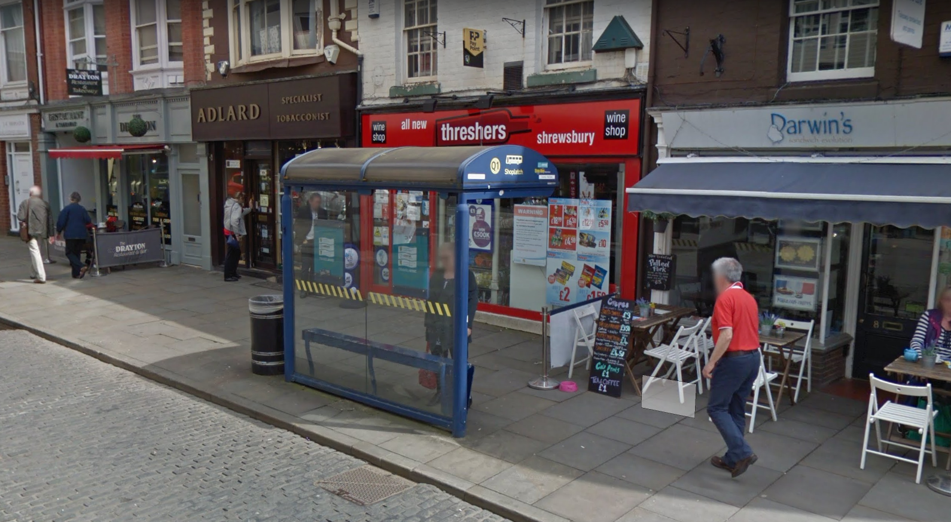

Depending on the location and usage bus shelters have either 2 or 3 panels, some have end panels and some have seating,

Over the years there has been a number of replacements of old shelters with new. Some shelters have been removed as bus routes have changed, but there are still a couple that are in situ nolonger on a bus route; these have a power supply and would require Western Power input to decommission.

A number of shelters are prone to vandalism; on average a new PVC Panel costs £200 to replace and we have had to revert to replacing glazing panels with mesh panels in some locations where ASB has been rife

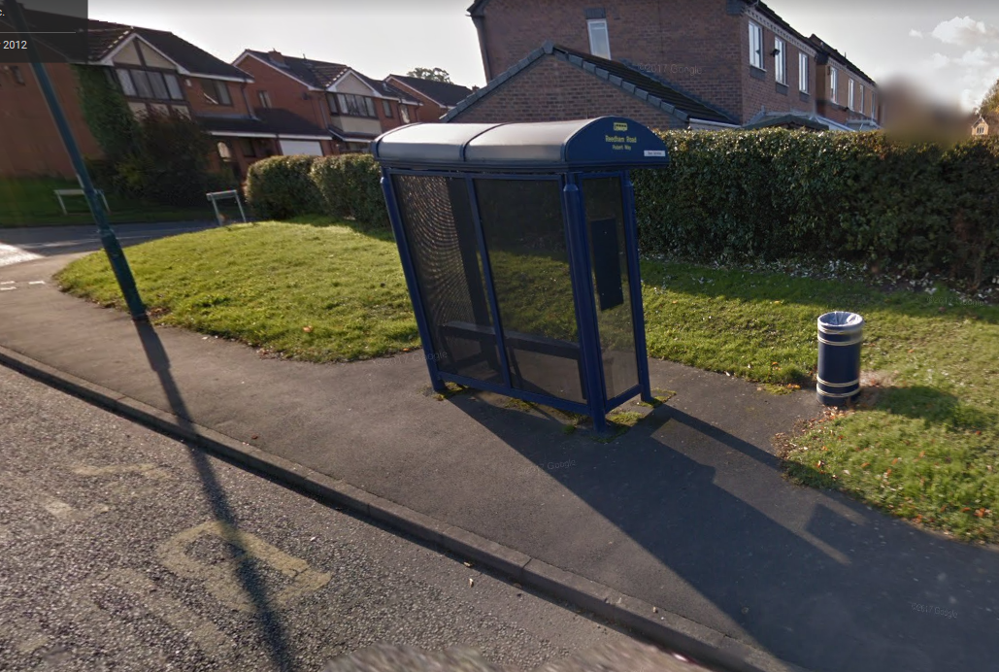

Whilst we have attempted to keep many of these bus shelters going, we are facing challenges of seeking spare parts. As an example, we can longer buy the perspex curved roof for Version 2 Bus Shelters.

We have sourced an alternative shelter to the Version 2 design www.queensburyshelters.co.uk. The standard 3m (2 bay shelter) with no end panels and no seating start at £3100.

Ongoing Repair & Maintenance

When time permits we aim to jet wash the bus shelters twice a year involving Toilet Cleaners and Neighbourhood Wardens, but in a year like 2018 when we have faced a number of long-term sickness absences, these are tasks that are deferred.

In undertaking an audit we have identified those in need of repair and painting and have now established the right pantone colours for the Blue & Gold rather than using inconsistent colour pallets as has been done in the past

New Bus Shelters

From time to time members have asked about adding bus shelters to bus routes. Whilst we maintain a budget for repair & maintenance we have no capital budget for new and replacement bus shelters. Therefore members would need to consider during budget setting discussions whether a budget allocation would be required.

In determining a policy for the installation of Bus Shelters members would need to think about the following:

General Principles for the Installation of Bus Shelters
- Shelters will be away from immediate frontages of residential properties
- Seek to ensure a safe, comfortabble waiting environment
- Keep street clutter to a minimum
- Respect the environment/Conservation Area
- Maximise protection from the elements
- Inform residents adjacent of the proposals
- Regular cleaning & maintenance

Choosing a Bus Shelter
- Ease of Maintenance &Repair
- Accessibility to the Shelter
- Visibility from the Shelter to the approaching bus
- Installation requirements
- Provision of Seating
- Prvision of Lighting
- Impact of Shelter on landscape & neighbouring properties
- Resistence to weathering/ASB
- Provision of Noticeboard/Timetable
- Consents/Permissions on private land
- Level of patronage & frequency of the Service
- Location
  - On an existing route at an existing stop
  - Space large enough to accommodate the shelter & a boarding area
  - Should have level, self-draining base
  - Must not obstruct visibility
  - Assessment for Highway Safety – 1.5m clear passage required
- Dealing with customer complaints – siting of Bus Shelters is a sensitive issue
  - Visual Disturbance
  - Highway Safety
  - Anti-Social Behaviour

Members need to consider whether the Town Council might have ongoing liability for the installation of bus shelters on development sites. This would be a matter for consideration by developers.

Issues for members consideration

- Policy on the installation of new bus shelters & allocation of an appropriate budget;

- Consideration of a replacement programme for existing bus shelters;

- Priority for the Cleaning, repair & maintenance of existing Bus Shelters

Appendix 1 - Bus Shelter List

BS16 | Abbey Foregate | By Abbey | 1 | Abbey
BS17 | Abbey Foregate | Opposite Dun Cow | 1 | Abbey
BS18 | Abbey Foregate | Outside Dun Cow | 1 | Abbey
BS19 | Abbey Foregate | Opposite Shirehall | 2 | Abbey
BS86 | Abbey Foregate | Opposite Bricklayer's Arms | 2 | Abbey
BS90 | Portland Crescent | Junction of Belvidere Road | 2 | Abbey
BS100 | Abbey Foregate | By Shirehall | 2 | Abbey
BS101 | Abbey Foregate | Adjacent to Car Park | MR2 | Abbey
BS80 | Hubert Way | Junction of Butterwick Drive | 2 | Bagley
BS81 | Hubert Way | Junction of Reedham Road | 2 | Bagley
BS82 | Hubert Way | Junction of Chelwood Drive | 2 | Bagley
BS3 | Whitchurch Road | At Crossroads | 2 | Battlefield
BS5 | Whitchurch Road | Opposite Doncasters | 2 | Battlefield
BS43 | Whitchurch Road | Adjacent to Rosedale | 2 | Battlefield
BS46 | Belle Vue Road | By Oakley Street | 1 | Battlefield
BS58 | Alberbury Drive | By Bridge Over Brook | MR2 | Battlefield
BS85 | Alberbury Drive | Junction of Whittington Close | 2 | Battlefield
BS24 | Hereford Road | Opposite Shops | 1 | Belle Vue
BS25 | Hereford Road | By BP Garage | 1 | Belle Vue
BS68 | Gyratory | Adjacent to Animal Trust Vets | 1 | Belle Vue
BS98 | Hereford Road | By The Rocks | 2 | Belle Vue
BS99 | Belle Vue Road | Adjacent to Greyfriars Road | 2 | Belle Vue
BS33 | Welshpool Road | By Shelton Gardens | 1 | Bowbrook
BS51 | Welshpool Road | By Racecourse Lane | 1 | Bowbrook
BS72 | Welshpool Road | By Severn Trent Water | 1 | Bowbrook
BS73 | Holyhead Road | By Oxon | 1 | Bowbrook
BS102 | Welshpool Road | By Former Shelton Hospital | MR2 | Bowbrook
BS103 | Welshpool Road | Opposite Supermarket | MR2 | Bowbrook
BS104 | Gains Park Way | Junction of Gains Park Avenue | MR2 | Bowbrook
BS106 | Gains Park Way | Near Onslow PH | MR2 | Bowbrook
BS109 | Gains Park Way | Junction of Woodcrest | 1 | Bowbrook
BS9 | Ditherington Road | Adjacent to Comet Drive | 2 | Castlefields & Ditherington
BS11 | New Park Road | Junction with North Street | 2 | Castlefields & Ditherington
BS47 | Sultan Road | Junction of New Park Road | 2 | Castlefields & Ditherington
BS66 | Ditherington Road | Opposite Site of Former Six Bells | 2 | Castlefields & Ditherington
BS20 | Sutton Way | Adjacent to Wenlock Road | 1 | Column
BS21 | Sutton Way | Adjacent to Sutton Road | 1 | Column
BS22 | Springfield Way | Adjacent to Springfield Green | 1 | Column
BS83 | London Road | By College | 2 | Column
BS84 | London Road | Junction of Ebnal Road | 2 | Column
BS113 | London Road | Emstrey Roundabout | 2 | Column
BS114 | London Road | Near Business Park | 2 | Column
BS31 | Mytton Oak Road | By Chestnut Close | 1 | Copthorne
BS32 | Mytton Oak Road | By Oakfield Road | 2 | Copthorne
BS48 | Mytton Oak Road | By Cruckton Close | 1 | Copthorne
BS105 | Copthorne Road | By Richmond Drive | MR2 | Copthorne
BS1 | Mt Pleasant Road | By Little Harlescott Lane | 1 | Harlescott
BS62 | Lancaster Road | Opposite Kynaston Road | 1 | Harlescott
BS63 | Gloucester Road | By Little Harlescott Lane | 1 | Harlescott
BS75 | Mt Pleasant Road | Junction of Lancaster Road | 1 | Harlescott
BS26 | Moneybrook Way | By Flats | 2 | Meole
BS27 | Moneybrook Way | By Garages | 2 | Meole
BS28 | Moneybrook Way | By Mary Webb Road | 2 | Meole
BS29 | Upper Road | Junction of Roman Road | 2 | Meole
BS95 | Alexandra Avenue | Junction of Washford Road | 2 | Meole
BS96 | Meole Crescent | By Vicarage Road | 2 | Meole
BS97 | Hereford Road | Junction of Upper Road | 2 | Meole
BS110 | Upper Road | Junction of Roman Road | 2 | Meole
BS13 | Clive Road | By Abbots Green | 1 | Monkmoor
BS14 | Monkmoor Road | By Abbots Road | 1 | Monkmoor
BS52 | Conway Drive | Outside Shops | 1 | Monkmoor
BS60 | Porchfields | Near Car Park | MR2 | Monkmoor
BS74 | Monkmoor Road | Junction of Clive Road | 1 | Monkmoor
BS91 | Belvidere Road | Adjacent to Belvidere Lane | 2 | Monkmoor
BS92 | Belvidere Road | Junction of Crowmere Road | 2 | Monkmoor
BS94 | Porchfields | Middle in Car Park | 2 | Monkmoor
BS30 | Longden Road | By Red Barn | 1 | Porthill
BS34 | Copthorne Road | By Barracks | 1 | Porthill
BS56 | Frankwell Island | By Flats | MR2 | Porthill
BS107 | Copthorne Road | By Bromley Court | MR2 | Porthill
BS108 | Woodfield Road | By Post Office | MR2 | Porthill
BS38 | St Mary's Street | Outside Church | 2 | Quarry & Coton Hill
BS39 | St Mary's Street | Outside Church | 2 | Quarry & Coton Hill
BS40 | Dogpole | Outside Old Guildhall | 2 | Quarry & Coton Hill
BS44 | Castle Foregate | Opposite New Park Road | 2 | Quarry & Coton Hill
BS49 | High Street | By The Square | 2 | Quarry & Coton Hill
BS53 | Barker Street | Opposite Rowley's House | 2 | Quarry & Coton Hill
BS55 | Barker Street | Opposite Rowley's House | 2 | Quarry & Coton Hill
BS57 | Castle Street | Junction of Windsor Place | 2 | Quarry & Coton Hill
BS59 | Castle Foregate | Opposite Sorting Office | 2 | Quarry & Coton Hill
BS70 | Castle Street | Opposite H&M | 2 | Quarry & Coton Hill
BS71 | Shoplatch | Outside Threshers Off-Licence | 2 | Quarry & Coton Hill
BS77 | Shoplatch | Outside Ashleys Wine Bar | 2 | Quarry & Coton Hill
BS78 | Smithfield Road | Castle Pointe | CI | Quarry & Coton Hill
BS79 | High Street | By The Square | 2 | Quarry & Coton Hill
BS54 | Bank Farm Road | In Lay-by | 1 | Radbrook
BS61 | Bank Farm Road | By Supermarket | 1 | Radbrook
BS64 | Radbrook Road | Opposite Old College Site | 1 | Radbrook
BS6 | Whitchurch Road | Off Heathgates Island | MR2 | Sundorne
BS7 | Sundorne Road | Coracle | MR2 | Sundorne
BS37 | Moston Road | Junction of Allerton Road | MR2 | Sundorne
BS41 | Moston Road | Junction of Sundorne Road | 2 | Sundorne
BS42 | Moston Road | Opposite Shops | MR2 | Sundorne
BS45 | Sundorne Road | Outside old TA Centre | 2 | Sundorne
BS65 | Sundorne Road | Off Heathgates Island | 2 | Sundorne
BS67 | Sundorne Road | Adjacent to Pimley Lane | 2 | Sundorne
BS69 | Meadow Farm Drive | By Church | 2 | Sundorne
BS2 | Old Potts Way | Outside ASDA | 2 | Sutton & Reabrook
BS8 | Hereford Road | Moneybrook Way | 2 | Sutton & Reabrook
BS10 | Old Potts Way | Outside Cinema |  | Sutton & Reabrook
BS23 | Tilstock Crescent | Middle | 1 | Sutton & Reabrook
BS50 | Old Potts Way | Opposite ASDA Entrance | 2 | Sutton & Reabrook
BS87 | Grove Road | Adjacent to Reabrook Avenue | 2 | Sutton & Reabrook
BS88 | Whitecroft Road | By Shops | 2 | Sutton & Reabrook
BS89 | Whitehart | By Garages | 2 | Sutton & Reabrook
BS111 | Old Potts Way | Outside Farr and Harris | 2 | Sutton & Reabrook
BS15 | Monkmoor Road | By Crowmere Road | 1 | Underdale
BS93 | Woodcote Way | Adjacent to Buttington Road | 2 | Underdale
BS112 | Woodcote Way | Opposite Severndale School | 2 | Underdale

